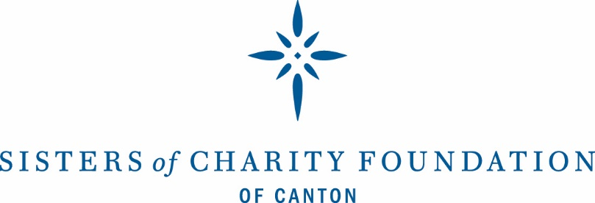

FOR IMMEDIATE RELEASE
Contact: Joni T. Close, President
Office: (330) 454-5800, ext. 303
Cell: (330) 309-3844
jclose@scfcanton.org
400 Market Avenue North, Suite 300
Canton, Ohio 44702

SISTERS OF CHARITY FOUNDATION awards $1,062,289

Canton, Ohio (May 29, 2020) The Board of Directors of the Sisters of Charity Foundation of Canton has announced $1,062,289 in grants for the first and second quarters of 2020.
Foundation President Joni Close stated, “The first quarter grants were awarded through the Foundation’s traditional grantmaking process, focusing on areas of interest related to our mission and goals. In mid-March, however, the world changed. From then on, grants were awarded through a community collaboration of more than a dozen foundations and donors working together in response to the pandemic. We are proud of the quick response from our community partners. The diversity of the organizations serving our community is impressive. And most importantly, we recognize, support, and honor all of the first responders and community organizations making a difference on the front lines.”
Grants were awarded to:
Foundation-Led Initiatives: Our efforts to develop and hone programs focused on systemic change. Total: $365,000
Groundwork Ohio, to support public opinion polling, coordinate and analyze a supply-and-demand study of Ohio’s child care services, and develop and disseminate a report on the economic impact of investing in high-quality early childhood services | $15,000
Stark County Mental Health and Addiction Recovery, to support the sustainability of Stark County’s behavioral health organizations, over three years | $350,000

Responsive Efforts: Our commitment to respond to specific or short-term community needs.
Total: $121,000
Christian Children's Home of Ohio, to support its Thrive art therapy program | $10,000
Goodwill Industries of Greater Cleveland and East Central Ohio, to support its parenting program | $40,000
OhioGuidestone, to support the renovation of a building in Dover that will be the new home of Harbor House Residential Treatment Facility | $25,000
St. Anthony/ All Saints, to support the Building Bridges Hispanic ministry program, over three years | $36,000
Stark County District Library, to support free books for young children across Stark county from the Dolly Parton and Ohio Governor’s Imagination Library program | $10,000

Our funding in partnership with the COVID19 community collaborative. Total: $564,789
Akron-Canton Regional Foodbank, to support Stark County food pantries | $27,500
Alliance Family Health Center, to support on-site medical services provided at all local shelter sites | $2,500
Association for Better Community Development, to support the purchase of personal protective equipment, disinfecting supplies, and professional vehicle cleaning services | $4,000
Child and Adolescent Behavioral Health, to support the purchase of cleaning supplies and services, cell phones, and operations | $35,000
Coleman Professional Services, to support the purchase of cleaning supplies, personal protective equipment, laptops, and client phone cards | $ 2,500
CommQuest Services, to support cleaning supplies, personal protective equipment, enclosing the receptionist area at the Cleveland Avenue location, and deep cleaning the Alliance outpatient office | $15,660
Domestic Violence Project, Inc., to support the purchase of food, diapers, formula, baby wipes, cleaning supplies, and shelter utility costs | $3,250
Domestic Violence Project, Inc., to support operations from June 1 through October 31, 2020 | $35,000
Early Childhood Resource Center, to support summer remediation programming for students in kindergarten through third grade | $25,000
Faith In Action of Western Stark County, to support rent, payroll expenses, and gas cards for volunteers | $2,500
Goodwill Industries of Greater Cleveland and East Central Ohio, to support Community Campus salaries and operating costs | $200,000
Greater Stark County Urban League, to support the purchase, packaging, and distribution of household cleaning and hygiene products for high-poverty households in Canton, Alliance, and Massillon | $2,000
ICAN, Housing, to support security, unpaid tenant rent, and remote work needs | $13,500
JRC, to support payroll expenses, operating costs, and equipment | $6,250
Massillon Family YMCA, to support pandemic child care at the Massillon and Navarre sites | $10,000
Pathway Caring for Children, to support operations and program expenses for foster parents | $35,000
Project Rebuild, to purchase twenty tablets and keyboards for students | $3,000
Siffrin, to support rent and vehicle leases | $35,000
Stark County Community Action Agency, to support the purchase of household cleaning and hygiene products | $2,000
Stark Community Support Network, to support client services, rent, utilities, and supplies | $6,500
Stark County Catholic Schools, to support technology | $11,000
Stark Housing Network, to support cleaning services for shelters | $16,500
The Workshops (TWi), to support gas cards for staff, staffing and materials for new activities for virtual day participants, and resources for 24/7 participants | $5,000
United Way of Greater Stark County, to support the emergency assistance fund for individuals in need of mortgage and rental assistance | $20,000
Vantage Aging, to support costs associated with the purchase of shelf-stable foods for clients | $23,129
YMCA of Central Stark County, to support the North Canton site’s function as a temporary pandemic child care center | $20,000
YWCA of Canton, to support unpaid rent of tenants in the rapid rehousing program | $3,000

Additional COVID grants provided through President’s discretionary grants. Total: $11,500
Association for Better Community Development, to support transportation for individuals living in a Homeless Continuum of Care of Stark County shelter or housing project who need medical transportation | $2,500
Canton City Public Health, to support care packages containing cleaning, disinfection, and personal hygiene supplies for individuals with chronic disease | $4,000
Stark Housing Network, to support cleaning supplies and personal protective equipment for shelters | $5,000
Established in 1996, the Sisters of Charity Foundation of Canton is a ministry of the Sisters of Charity Health System. Based on the vision of the Sisters of Charity of St. Augustine, the Foundation is committed to addressing the needs of the poor and underserved by understanding the root causes of poverty, nurturing the growth of healthy communities, emphasizing youth and family, and measuring the outcomes of these efforts.
The Sisters of Charity Foundation of Canton reviews grants on a rolling basis. Information on the grant application process is available at www.scfcanton.org

- END -

